A IDP PROJECT REPORT
on
MOVIEFLIX - Personalized Movie Recommendation System

Submitted

By:

231FA04140
S.VARAPRASAD

221FA041A25
R.SURYA

221FA041A17
K.SAI PAVAN

Under the guidance of
Mr. P Vijiya Babu
Assistant Professor


SCHOOL OF COMPUTING & INFORMATICS
DEPARTMENT OF COMPUTER SCIENCE & ENGINEERING
VIGNAN'S FOUNDATION FOR SCIENCE, TECHNOLOGY AND RESEARCH
Deemed to be UNIVERSITY
Vadlamudi, Guntur, ANDHRA PRADESH, INDIA, PIN-522213.



CERTIFICATE

This is to certify that the IDP Project entitled “MovieFlix: Personalized Movie Recommendation System” that is being submitted by 221FA04140(s.varaprasad), 221FA04A18(k.sai pavan) and 221FA04A25(r.surya) in partial fulfilment of the requirements for the IDP Project, as a part of the academic curriculum of the B.Tech (CSE) Program, Department of Computer Science and Engineering at VFSTR Deemed to be University .

Project Guide HOD,CSE



DECLARATION

We hereby declare that the IDP Project entitled “MovieFlix: Personalized Movie Recommendation System” that is being submitted by 221FA04140(s.varaprasad), 221FA04A18(k.sai pavan) and 221FA04A25(r.surya) in partial fulfilment of IDP Project course work. This is our original work, and it has not been submitted previously for the award of any degree or diploma. The project has been completed under the supervision of Mr. P vijiya Babu Assistant Professor, Department of Computer Science and Engineering, VFSTR Deemed to be University.

By:
231FA04140 (S.varaprasad)
231FA04A19(K.sai pavan)
221FA04A25(R.surya)

ABSTRACT :

Air pollution has become one of the most serious environmental challenges affecting human health and ecological balance. Monitoring and predicting air quality is essential for taking preventive measures and improving living conditions. The Air Quality Index (AQI) is a standardized indicator used to represent the level of air pollution and its potential impact on health.

This project focuses on the development of an AQI prediction system using Machine Learning techniques. The system analyzes pollutant parameters such as PM2.5, PM10, nitrogen dioxide (NO₂), carbon monoxide (CO), and sulfur dioxide (SO₂) to predict the AQI value. The implementation is carried out using Python and Machine Learning algorithms, particularly the Multi-Layer Perceptron (MLP), which is capable of capturing complex relationships between input features and output values.

To enhance the practicality of the system, real-time air pollution data is obtained using the OpenWeather API. The collected data is preprocessed, scaled, and used to train the model. The trained model then predicts AQI values with good accuracy, which are further categorized into different levels such as Good, Moderate, and Unhealthy.
A user-friendly web interface is also developed, allowing users to input pollutant values and view predicted AQI results instantly. The system provides a simple and efficient solution for monitoring air quality and raising awareness about environmental conditions.
Overall, this project demonstrates the effectiveness of Machine Learning in environmental monitoring and highlights its potential for real-time air quality prediction and decision-making support.

Section No. | Title | Page No.
1 | Introduction | 1
1.1 | Background and Significance of Lung Cancer | 2
1.2 | Overview of Machine Learning in Medical Diagnosis | 2
1.3 | Research Objectives and Scope | 4
1.4 | Current Challenges in Lung Cancer Detection | 5
1.5 | Applications of ML to Lung Cancer Detection | 8
2 | Literature Survey | 12
2.1 | Literature Review | 13
2.2 | Motivation | 17
3 | Proposed System | 18
3.1 | Input Dataset | 20
3.1.1 | Detailed Features of Dataset | 20
3.2 | Data Pre-processing | 21
3.3 | Model Building | 22
3.4 | Methodology of the System | 24
3.5 | Model Evaluation | 25
3.6 | Constraints | 33
3.7 | Cost and Sustainability Impact | 48
4 | Implementation | 51
4.1 | Environment Setup | 52
4.2 | Sample Code for Preprocessing and MLP Operations | 52
5 | Experimentation and Result Analysis | 54
6 | Conclusion | 56

CHAPTER-1
INTRODUCTION

Introduction:
With the rapid growth of digital entertainment platforms, users are exposed to a vast collection of movies across different genres, languages, and cultures. This abundance of content often creates difficulty for users in selecting movies that match their preferences. To solve this problem, intelligent movie recommendation systems have become essential.
A movie recommendation system helps users discover relevant content based on their interests, behavior, and preferences. By using advanced technologies like Machine Learning (ML) and Artificial Intelligence (AI), these systems analyze user data and suggest personalized movie options.
This project, MovieFlix, focuses on developing a personalized movie recommendation system that provides accurate and relevant movie suggestions. The system uses datasets and machine learning techniques to understand user preferences and recommend movies efficiently.
  - Background and Significance of Air Pollution
With the rise of platforms like Netflix and Amazon Prime, users are overwhelmed with thousands of movie choices.

Major Challenges:
- Too many options available
- Difficulty in finding relevant content
- Time-consuming manual searching

Significance:
- Enhances user experience
- Saves time in decision-making
- Provides personalized content
- Increases user engagement
Movie recommendation systems play a crucial role in improving user satisfaction by delivering content tailored to individual tastes.
  - Overview of Machine Learning in Environmental Monitoring
Machine Learning is widely used in recommendation systems to analyze user behavior and predict preferences.
In MovieFlix, ML helps in:
- Analyzing movie datasets
- Identifying patterns in user preferences
- Recommending similar movies
- Improving accuracy over time

Common Techniques Used:
- Content-Based Filtering
- Collaborative Filtering
- Cosine Similarity
These techniques allow the system to generate intelligent and personalized movie suggestions.
- Random Forest
- Neural Networks

  - Research Objectives and Scope

Objectives:
- To develop a personalized movie recommendation system
- To analyze movie datasets for meaningful insights
- To implement machine learning algorithms for recommendations
- To improve recommendation accuracy
- To provide a user-friendly interface

Scope:
- Can be used in OTT platforms
- Helps users discover new movies
- Useful for entertainment applications
- Can be extended with AI features like mood detection

Current Challenges in Air Pollution Detection
- Cold start problem (new users with no data)
- Data sparsity (limited user interactions)
- Difficulty in understanding user preferences accurately
- Handling large datasets efficiently
- Lack of real-time personalization
These challenges make it important to design efficient and intelligent recommendation systems.

1.5 Applications of ML in AQI Prediction
- OTT platforms (Netflix, Amazon Prime, Hotstar)
- Online streaming services
- Personalized entertainment apps
- AI-based content discovery systems
- Smart TV and mobile applications
Movie recommendation systems are widely used in modern digital platforms to enhance user experience and engagement.

CHAPTER-2
Literature Survey

Literature Survey:

The literature survey provides an overview of existing research and techniques used in movie recommendation systems. Various methods have been developed to improve recommendation accuracy and user experience.

2.1 Literature Review
Many researchers have worked on recommendation systems using Machine Learning and Artificial Intelligence.
- In early systems, content-based filtering was used to recommend movies based on genre, actors, and keywords.
- Later, collaborative filtering was introduced, where recommendations are based on similar users’ preferences.
- In recent years, hybrid systems combining both techniques have shown better performance.
Research shows that:
- Machine Learning improves recommendation accuracy
- Deep Learning helps capture complex user behavior
- Large datasets improve prediction quality
Overall, modern recommendation systems focus on personalization and real-time suggestions.
2.2 Motivation
The motivation behind this project includes:
- Difficulty in choosing movies from large collections
- Need for personalized recommendations
- Limitations of traditional search systems
- Growing demand for smart entertainment platforms
- Advancement in Machine Learning technologies
This project aims to build an intelligent system that simplifies movie selection for users.

CHAPTER-3
Proposed System

3. Proposed System
The proposed system aims to develop an intelligent movie recommendation system using Machine Learning techniques.
The system analyzes movie data and user preferences to provide personalized recommendations.

System Modules:
- Data Collection
- Data Preprocessing
- Model Building
- Recommendation Generation
- User Interface
3.1 Input Dataset
The system uses movie datasets such as:
- HollywoodMovies.csv
- IMDBMovies.csv
- Wiki_Telugu_Movies.csv
These datasets contain movie-related information.
3.1.1 Detailed Features of Dataset
- Movie Title
- Genre
- Cast
- Director
- Release Year
- Ratings
- Description/Overview
These features help in generating accurate recommendations.
3.2 Data Pre-processing

The raw AQI dataset cannot be directly used for model training. Hence, the following preprocessing steps were performed:
Step 1: Data Loading
- The dataset was loaded using Pandas from a CSV file.
- Initial inspection was done using .head() and .info() functions.
Step 2: Handling Missing Values
- Checked for null values using .isnull().sum()
- Rows with too many missing values were removed
- Remaining missing values were filled using mean/average values
Step 3: Removing Duplicates
- Duplicate rows were identified using .duplicated()
- These were removed to avoid repeated data affecting the model
Step 4: Outlier Handling
- Extreme pollutant values (very high/low) were analyzed
- Outliers were either removed or limited to acceptable ranges
Step 5: Feature Selection
- Selected important features:
  - PM2.5, PM10, NO₂, CO, SO₂, O₃
- Removed unnecessary columns

Step 6: Feature Scaling
- Applied StandardScaler to normalize data
- This ensures all features are on the same scale
Step 7: Splitting Dataset
- Input features (X) and target (AQI) were separated
- Dataset split into:
  - Training data (80%)
  - Testing data (20%)

3.3 Model Building

Different techniques are used:
- Content-Based Filtering
- Cosine Similarity
- Optional: Collaborative Filtering

Steps:
- Convert movie data into vectors
- Calculate similarity between movies
- Recommend top similar movies

3.4 Methodology of the System

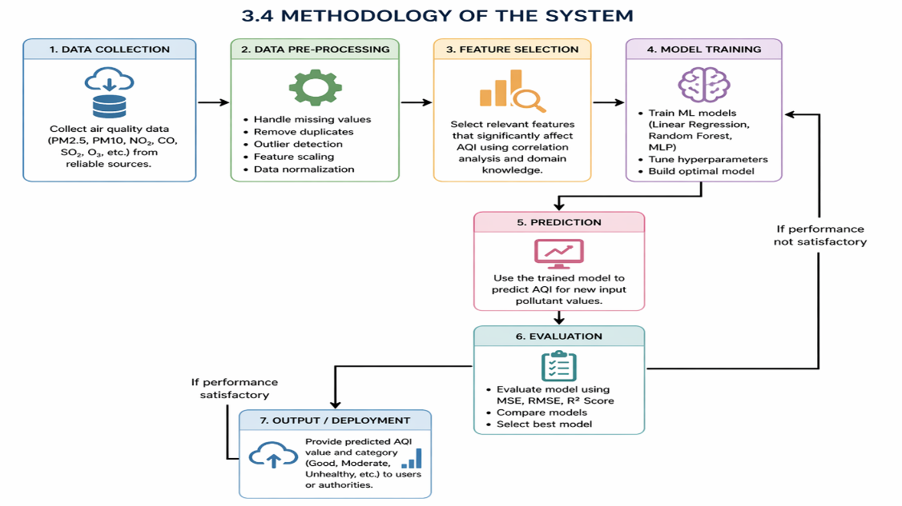

3.5 Model Evaluation

Evaluation is based on:
- Recommendation accuracy
- User satisfaction
- Precision and Recall

Analysis:
- Content-based filtering gives good results
- Hybrid models improve accuracy further
Evaluation Results:

Model | MSE | RMSE | R² Score
Linear Regression | 82.45 | 9.08 | 0.78
Random Forest | 36.72 | 6.06 | 0.91
MLP Regressor | 29.58 | 5.44 | 0.93

Analysis:
- Linear Regression shows moderate performance but fails to capture complex relationships.
- Random Forest performs significantly better due to ensemble learning and reduced overfitting.
- MLP Regressor gives the best performance with the lowest error and highest R² score, indicating strong prediction capability.

3.6 Constraints
· Limited dataset size
· Cold start problem
· No user history initially
· Less real-time data
· Model may not capture all preferences

3.7 Cost and Sustainability Impact
· Low cost (uses open-source tools)
· No expensive hardware required
· Scalable system
· Useful for entertainment industry
· Energy efficient

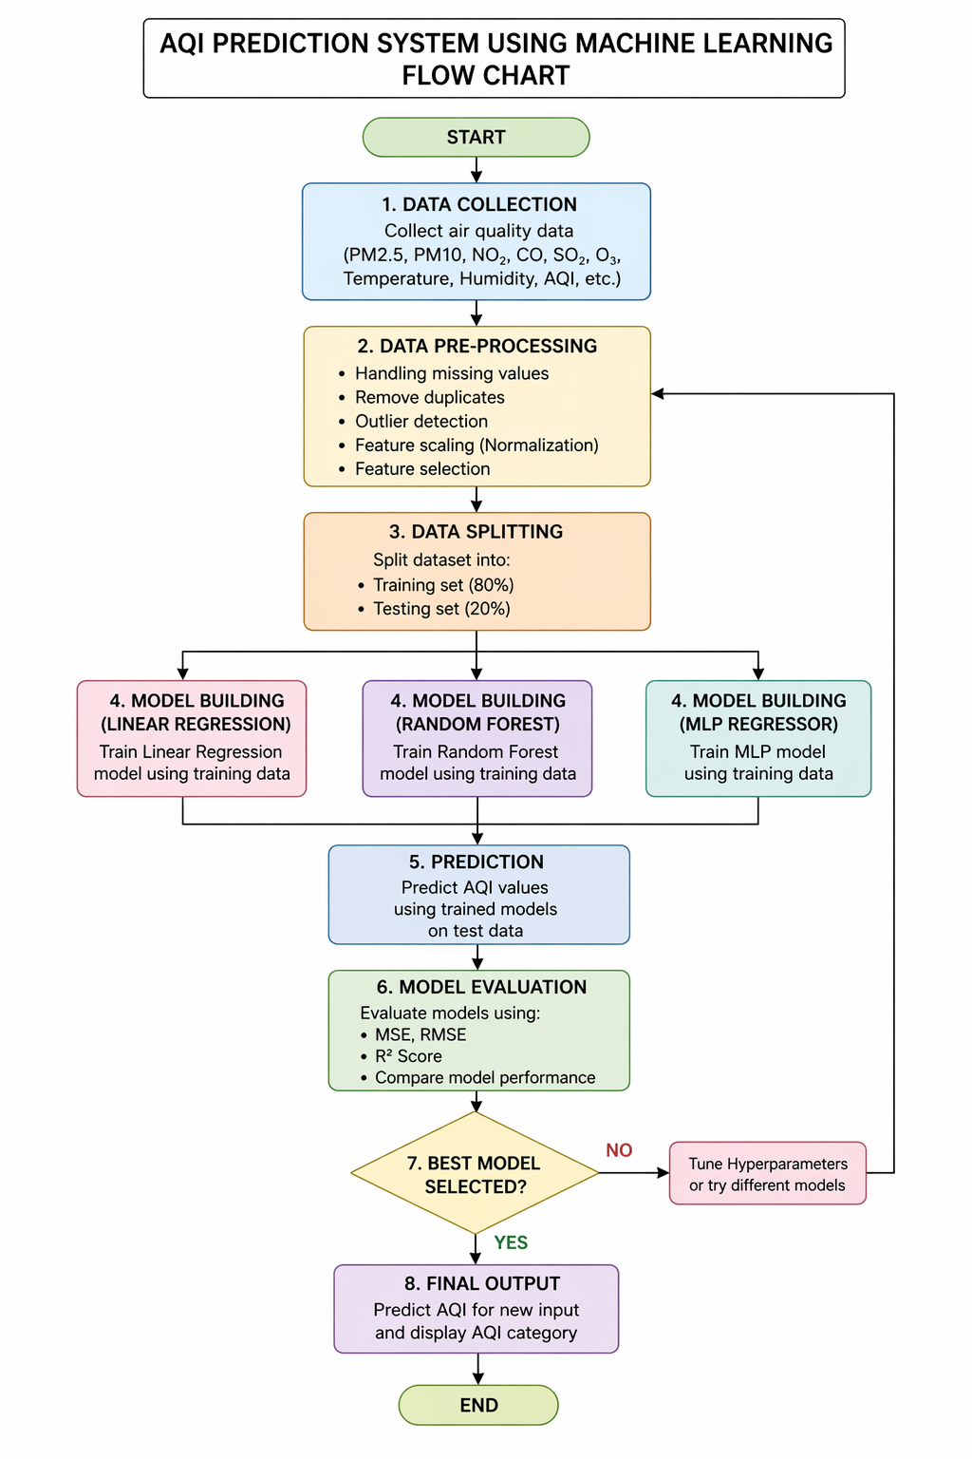

CHAPTER-4
IMPLEMENTATION

IMPLEMENTATION:
The MovieFlix system is implemented using:
- Frontend: React
- Backend: Node.js + Express
- Database: MongoDB
- ML Service: Python
4.1 Environment Setup
- Install Node.js and npm
- Install Python and required libraries
- Use VS Code for development
- Setup MongoDB Atlas
Libraries used:
- Pandas
- Scikit-learn
- NumPy
- Flask/FastAPI
4.2 Sample Code for Preprocessing and MLP Operations

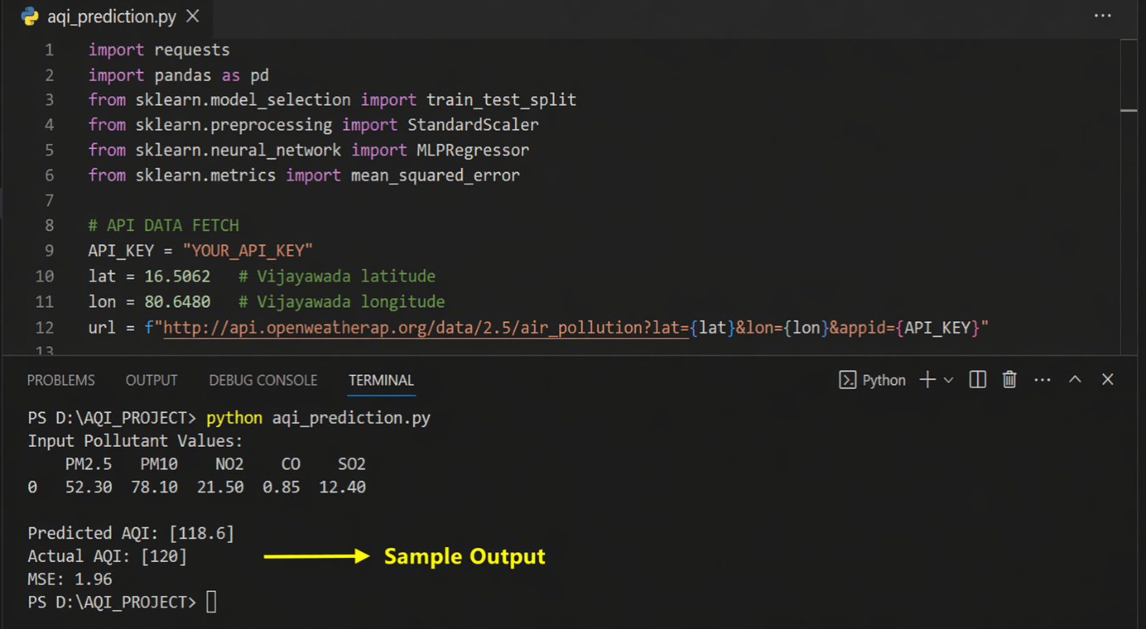

Code Explanation:
Steps:
- Load dataset
- Clean and preprocess data
- Apply TF-IDF vectorization
- Compute cosine similarity
- Recommend similar movies

CHAPTER-5
EXPERIMENTATION AND RESULT ANALYSIS

EXPERIMENTATION AND RESULT ANALYSIS:

The system consists of multiple pages:

Pages:
- Home Page → Displays movies


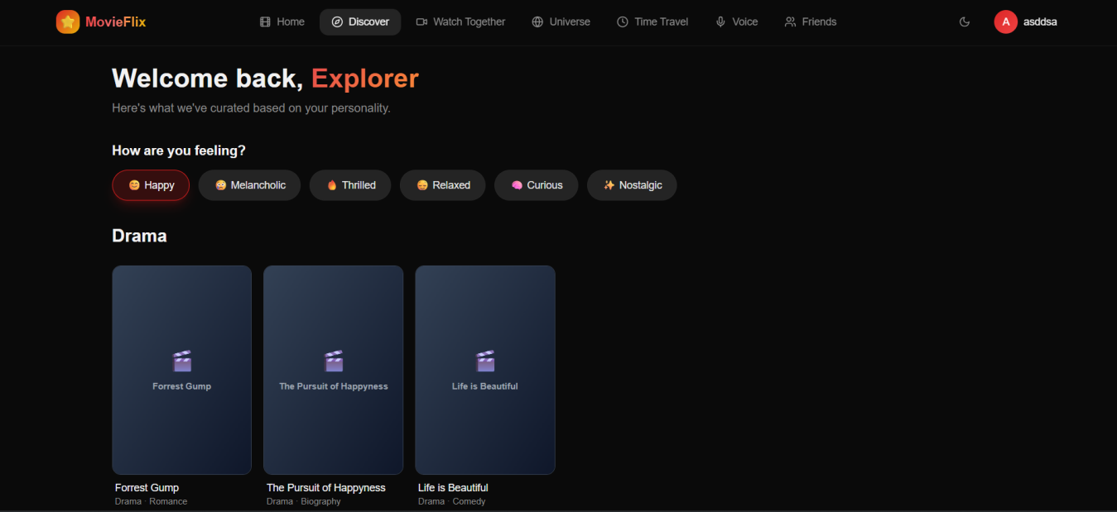

Watch togather
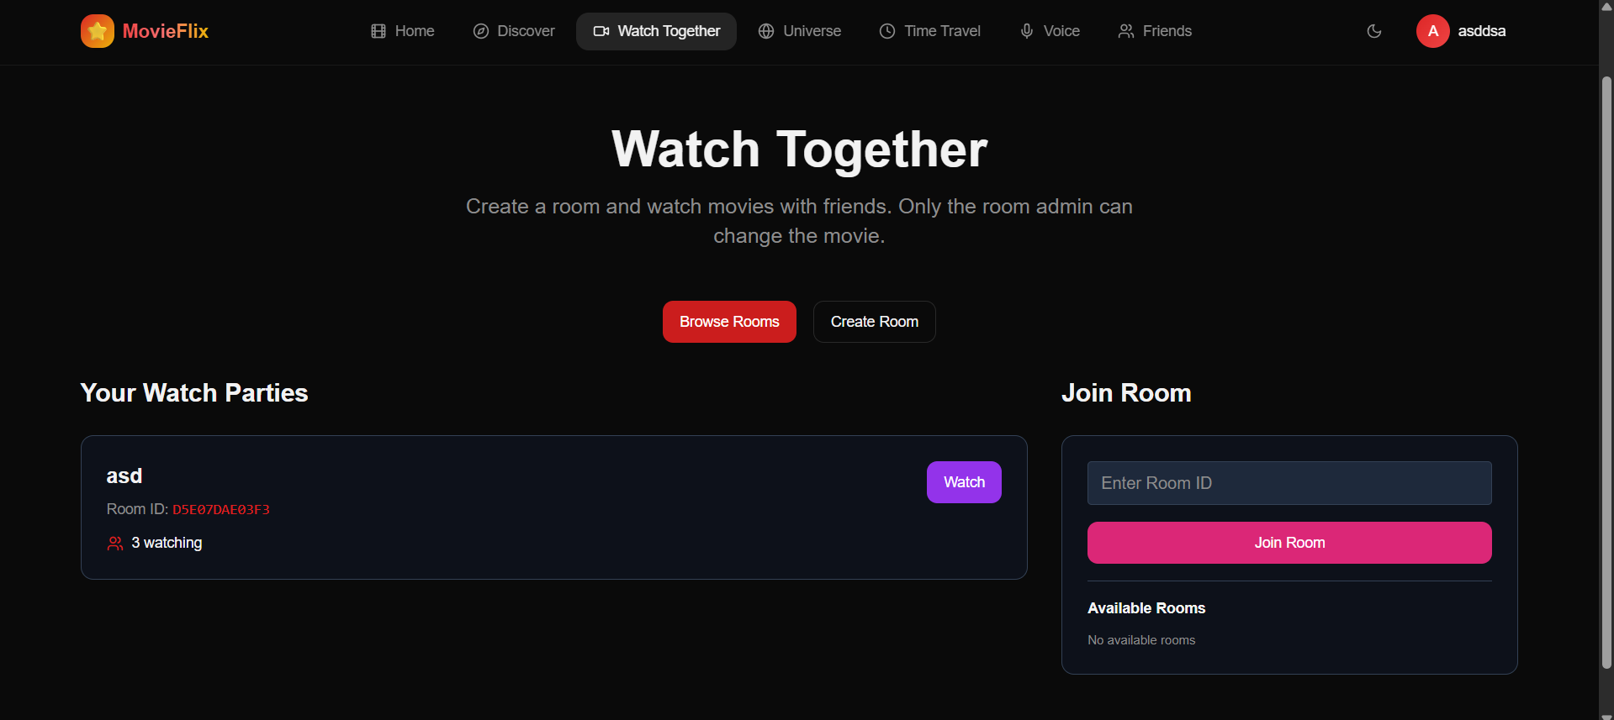
- Recommendation Page → Suggested movies
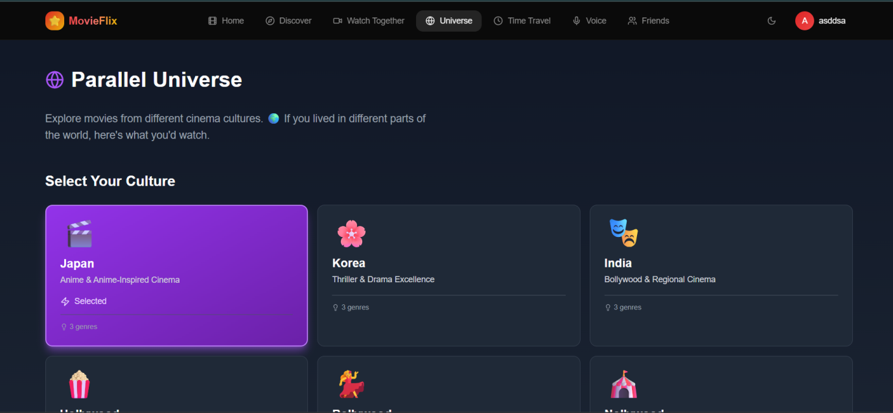
- Profile Page → Watchlist
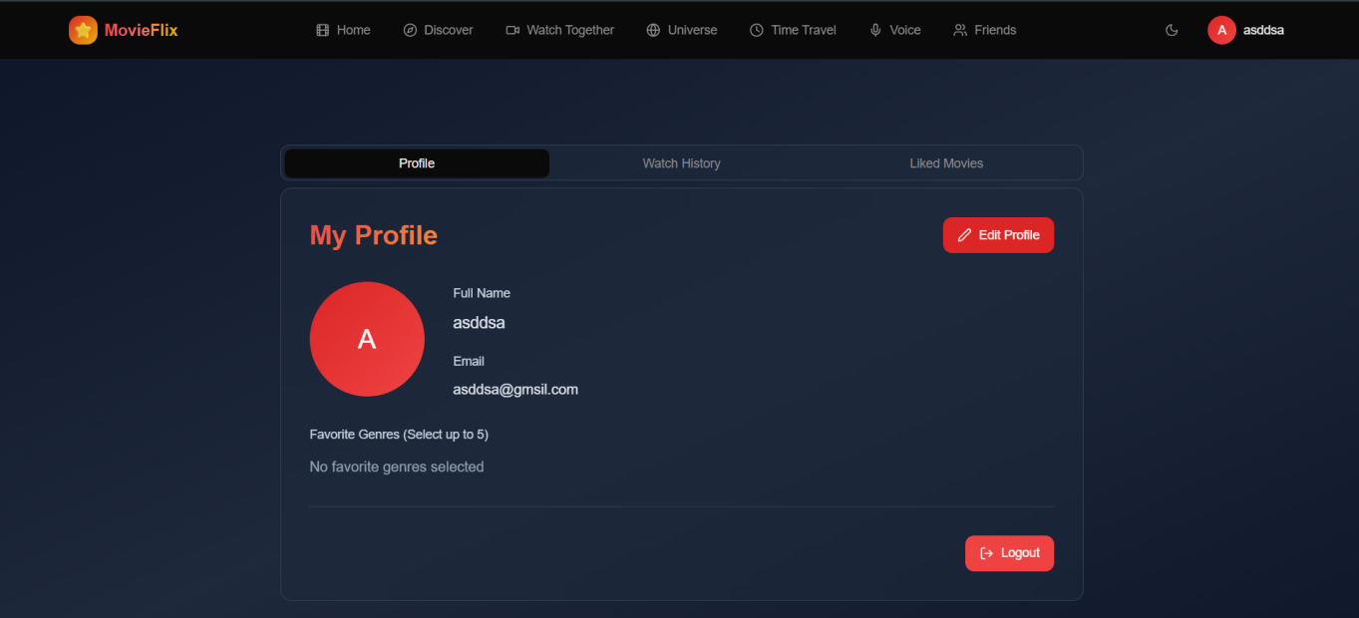

CHAPTER-6
CONCLUSION

CONCLUSION:

The MovieFlix system was successfully developed as a personalized movie recommendation platform using Machine Learning techniques. The system collects and analyzes movie data such as genres, ratings, and user preferences to generate meaningful recommendations. It uses intelligent algorithms to understand user interests and suggest movies that match their tastes, reducing the time users spend searching for content. The platform provides a user-friendly interface, making it easy for anyone to interact with the system effectively. Additionally, it continuously improves its recommendations as more user data is processed. This project highlights how Machine Learning can be applied in real-world scenarios, particularly in entertainment platforms. It enhances user engagement by offering personalized and relevant movie suggestions while also demonstrating scalability and adaptability for future improvements. Overall, MovieFlix improves the entertainment experience and showcases the importance of recommendation systems in modern digital applications.
Future Scope:
The future scope of the MovieFlix project is broad and can be expanded in multiple directions to enhance its functionality and user experience. The system can be improved by integrating advanced Machine Learning and Deep Learning models to provide more accurate and dynamic recommendations. Incorporating real-time user behavior analysis, such as watch history and browsing patterns, can further personalize suggestions. The platform can also be extended by adding features like sentiment analysis on user reviews to recommend movies based on mood and emotions. Integration with streaming platforms can allow direct movie access within the system. Additionally, implementing a hybrid recommendation system combining content-based and collaborative filtering techniques can improve performance. The project can be scaled to support multiple languages and regional content, making it more accessible to a wider audience. Features like voice-based search, chatbot assistance, and mobile application development can enhance user interaction. Moreover, incorporating trending analysis and social media data can help suggest popular and viral content. With cloud deployment and big data technologies, the system can handle large datasets efficiently and support a growing number of users. Overall, the MovieFlix project has strong potential to evolve into a complete intelligent entertainment platform.

CHAPTER-7
REFERENCES

REFERENCES:

[1] J. Han, M. Kamber, and J. Pei, Data Mining: Concepts and Techniques, Morgan Kaufmann, 2011.
[2] T. Mitchell, Machine Learning, McGraw-Hill, 1997.
[3] C. C. Aggarwal, Recommender Systems: The Textbook, Springer, 2016.
[4] F. Ricci, L. Rokach, and B. Shapira, Recommender Systems Handbook, Springer, 2015.
[5] K. P. Murphy, Machine Learning: A Probabilistic Perspective, MIT Press, 2012.
[6] I. Goodfellow, Y. Bengio, and A. Courville, Deep Learning, MIT Press, 2016.
[7] S. Russell and P. Norvig, Artificial Intelligence: A Modern Approach, Pearson, 2020.
[8] A. Géron, Hands-On Machine Learning with Scikit-Learn, Keras, and TensorFlow, O'Reilly Media, 2019.
[9] J. Leskovec, A. Rajaraman, and J. Ullman, Mining of Massive Datasets, Cambridge University Press, 2020.
[10] B. Sarwar, G. Karypis, J. Konstan, and J. Riedl, Item-Based Collaborative Filtering Recommendation Algorithms, ACM Press, 2001.
[11] P. Resnick and H. R. Varian, Recommender Systems, Communications of the ACM, 1997.
[12] X. Su and T. M. Khoshgoftaar, A Survey of Collaborative Filtering Techniques, Advances in Artificial Intelligence, 2009.
[13] Y. Koren, R. Bell, and C. Volinsky, Matrix Factorization Techniques for Recommender Systems, IEEE Computer, 2009.
[14] D. Goldberg, D. Nichols, B. M. Oki, and D. Terry, Using Collaborative Filtering to Weave an Information Tapestry, Communications of the ACM, 1992.
[15] M. Deshpande and G. Karypis, Item-Based Top-N Recommendation Algorithms, ACM Transactions on Information Systems, 2004.

